Supporting Information for

Forecasting

Benchmarking Real-time Streamflow Forecast Skill in the Himalayan Region

**Ganesh R Ghimire1, *, Sanjib Sharma2, Jeeban Panthi3, Rocky Talchabhadel4, Binod Parajuli5, and Piyush Dahal6**

1IIHR Hydroscience and Engineering, The University of Iowa, Iowa City, Iowa, USA; [ganeshghimire1986@gmail.com](mailto:ganeshghimire1986@gmail.com)

2Earth and Environmental Systems Institute, The Pennsylvania State University, University Park, PA, USA; [sanjibsharma66@gmail.com](mailto:sanjibsharma66@gmail.com)

3 Department of Geosciences, University of Rhode Island, Kingston, RI, USA; [Panthijeeban@gmail.com](mailto:Panthijeeban@gmail.com)

4 Kyoto University, Japan; [rocky.ioe@gmail.com](mailto:rocky.ioe@gmail.com)

5 Department of Hydrology and Meteorology, Nepal; [binodparaj@gmail.com](mailto:binodparaj@gmail.com)

6 Small Earth Nepal, Nepal; [piyush.dahal@gmail.com](mailto:piyush.dahal@gmail.com)

**\*** Correspondence: [ganeshghimire1986@gmail.com](mailto:ganeshghimire1986@gmail.com); Tel.: +1 618-340-2613

**Contents of this file**

Figures S1

Figures S2

Figures S3

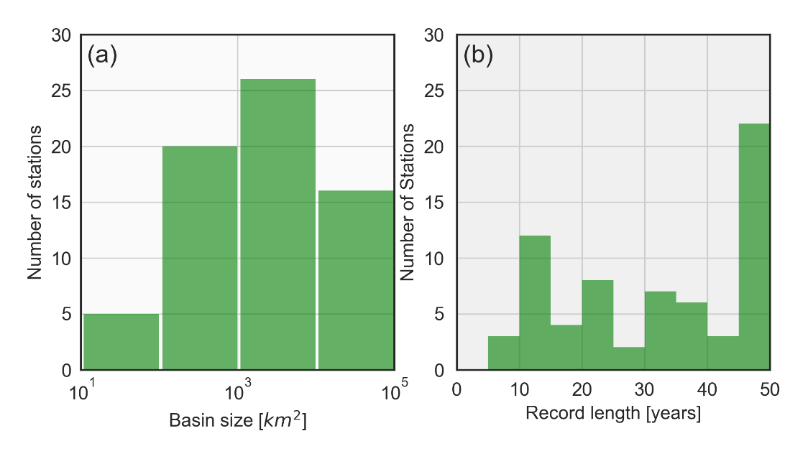

**Figure S1.** Histograms showing the distribution of upstream drainage area (a) and streamflow record length (b) associated with the stream gauge stations in Nepal

**Figure S2.** Demonstration of streamflow separation using HYSEP. Area highlighted in the blue represents the baseflow while the remaining area represents the direct run-off component. (a) and (b) correspond to the small river basin (159 km2) and the large river basin (42890km2), respectively.

**Figure S3.** Relationship between KGE and drainage area across lead-times for the intermittent flow rivers